ASSIGNMENT-6.1
NAME:G. Kalyan
H.NO:2303A51853
Batch=13

Task Description #1 (AI-Based Code Completion for Loops)
Task: Use an AI code completion tool to generate a loop-based
program.
Prompt:
“Generate Python code to print all even numbers between 1 and N
using a loop.”
Expected Output:
• AI-generated loop logic.
• Identification of loop type used (for or while).
• Validation with sample inputs.
PROMPT:
#Generate Python code to print all even numbers between 1 and N using a loop.
CODE:
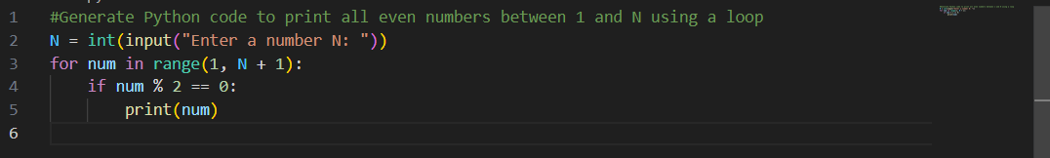
OUTPUT:
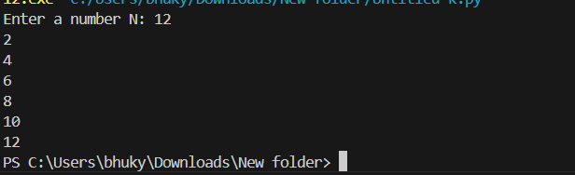
Justification:
Using AI to create loop-based programs speeds up learning by providing an immediate, correct example. This allows students to concentrate on grasping the logic behind identifying even numbers through conditional statements, instead of getting stuck troubleshooting loop syntax errors.

Task Description #2 (AI-Based Code Completion for Loop with
Conditionals)
Task: Use an AI code completion tool to combine loops and
conditionals.
Prompt:
“Generate Python code to count how many numbers in a list are even
and odd.”
Expected Output:
• AI-generated code using loop and if condition.
• Correct count validation.
• Explanation of logic flow.
PROMPT:
#Generate Python code to count how many numbers in a list are even and odd.
CODE:
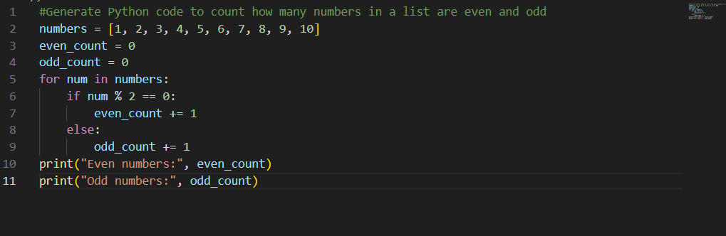
OUTPUT:
Justification:
AI support enhances the clarity of code by generating clean, well-organized logic. As a result, students can more easily see how control flow operates when loops and conditional statements interact in practical programming scenarios.

Task Description #3 (AI-Based Code Completion for Class
Attributes Validation)
Task: Use an AI tool to complete a Python class that validates user
input.
Prompt:
“Generate a Python class User that validates age and email using
conditional statements.”
Expected Output:
• AI-generated class with validation logic.
• Verification of condition handling.
• Test cases for valid and invalid inputs.
PROMPT:
#Generate a Python class User that validates age and email using
conditional statements.

CODE:
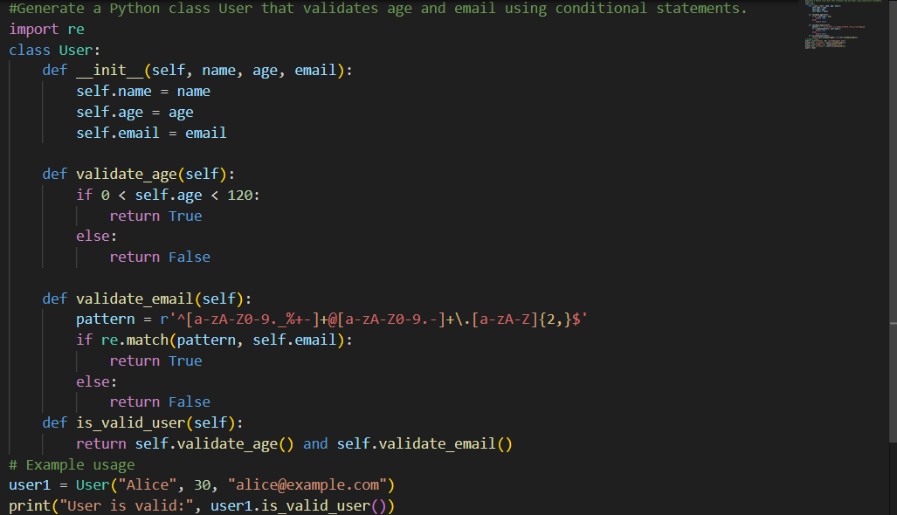
OUTPUT:

Justification :
By generating object-oriented validation code, AI helps learners understand how real-world rules can be enforced using classes and conditionals, promoting better programming practices.

Task Description #4 (AI-Based Code Completion for Classes)
Task: Use an AI code completion tool to generate a Python class for
managing student details.
Prompt:
“Generate a Python class Student with attributes (name, roll number,
marks) and methods to calculate total and average marks.”
Expected Output:
• AI-generated class code.
• Verification of correctness and completeness of class
structure.
• Minor manual improvements (if needed) with justification.
PROMPT:
#Generate a Python class Student with attributes (name, roll number,
marks) and methods to calculate total and average marks.

CODE:
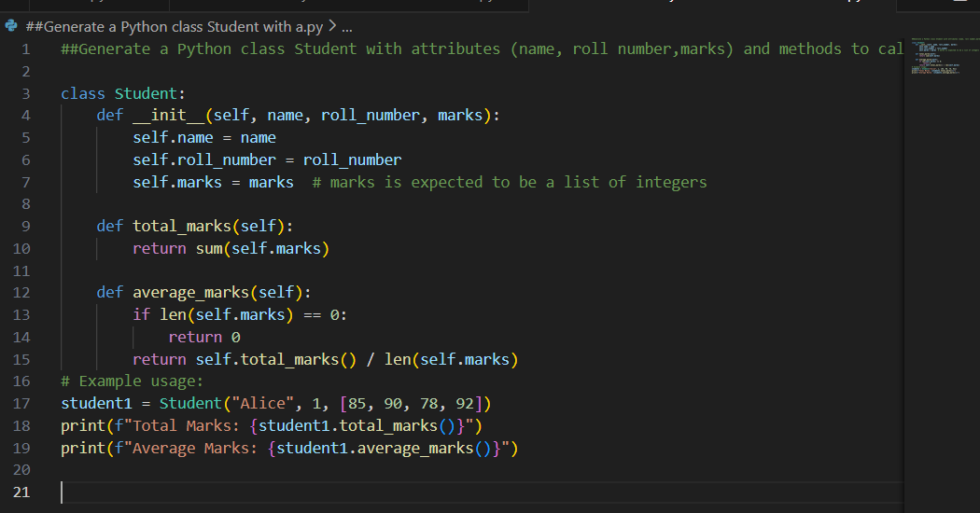

OUTPUT:
Justification :
The AI-generated class provides a clear example of how data (attributes) and behavior (methods) are combined in object-oriented programming, making it easier for students to grasp OOP concepts.

Task Description 5 (AI-Assisted Code Completion Review)
Task: Use an AI tool to generate a complete Python program using
classes, loops, and conditionals together.
Prompt:
“Generate a Python program for a simple bank account system using
class, loops, and conditional statements.”
Expected Output:
• Complete AI-generated program.
• Identification of strengths and limitations of AI suggestions.
• Reflection on how AI assisted coding productivity
PROMPT:
#Generate a Python program for a simple bank account system using
class, loops, and conditional statements.

CODE:
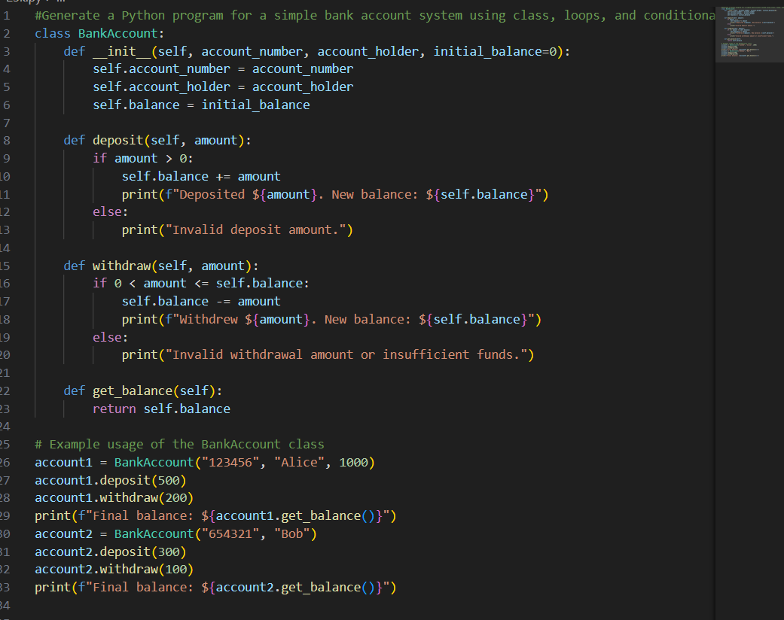

OUTPUT:
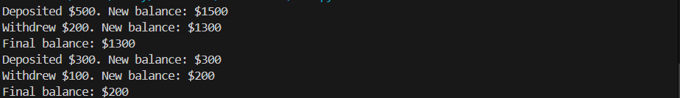
Justification :
Reviewing AI-generated programs helps identify strengths and limitations of automated suggestions. This encourages critical thinking and helps developers understand when manual improvements are necessary, leading to better overall code quality.

